- DNS & DHCP TROUBLESHOOTING ASSIGNMENT

Q1. Simulate a DNS Resolution Failure Using the Windows Hosts File
Objective: Force www.spotify.com to resolve to an incorrect test IP address, clear the DNS cache, and observe the result.
- Open Notepad as Administrator.
- Open C:\Windows\System32\drivers\etc\hosts. Select “All Files” in the Open dialog so the hosts file is visible.
- Add a line such as: 203.0.113.99 www.spotify.com. This is a documentation/test address and is intentionally incorrect for Spotify.
- Save the hosts file and open Command Prompt.
- Run ipconfig /flushdns so Windows clears cached DNS information.
- Run ping www.spotify.com. Windows should show that the name resolves to the wrong address. The ping may show “Request timed out” or another failure depending on the chosen address/network.
- After the practical, remove the added hosts-file line and run ipconfig /flushdns again to restore normal resolution.
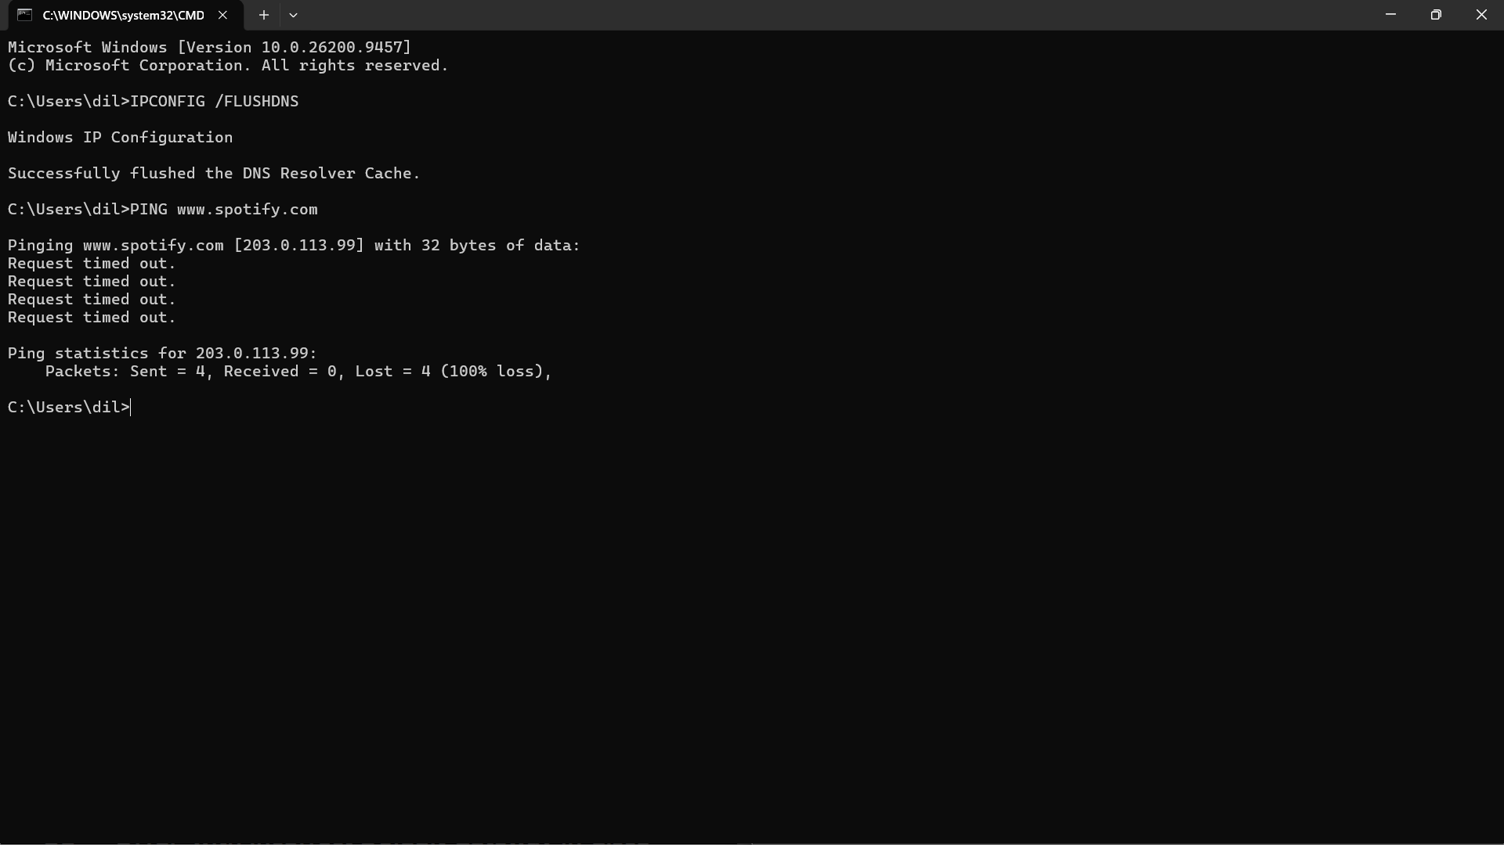
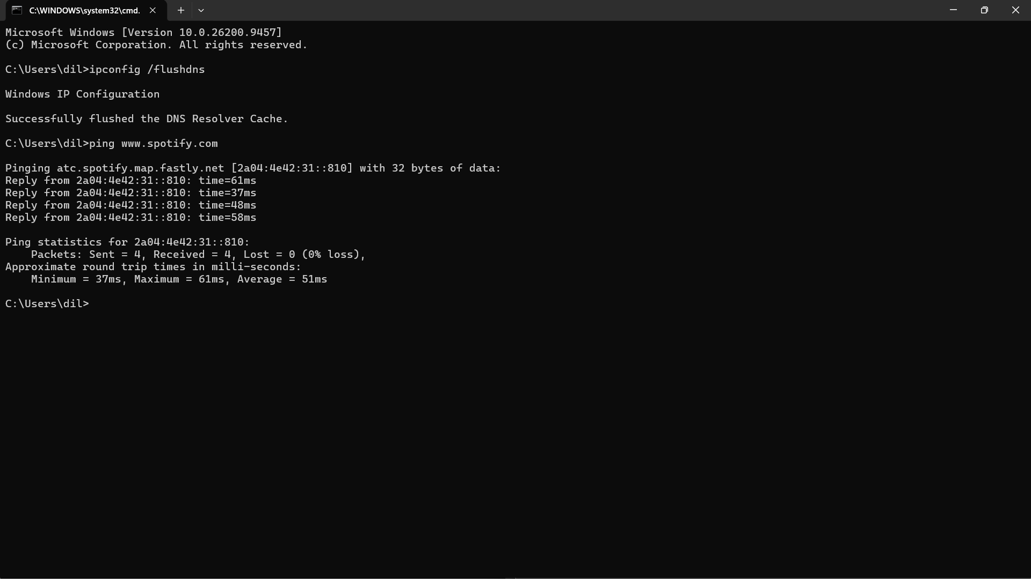

Observation: The hosts file overrides normal DNS lookup on the local machine. Because the domain was mapped to the wrong address, the ping targeted that incorrect address instead of the real service address.

Q2. Configure DHCP with an Incorrect Default Gateway in Packet Tracer
Example network: Router — Switch — DHCP Server — Client PC. Use 192.168.10.0/24 for the LAN. The correct router address is 192.168.10.1, but the DHCP pool is intentionally configured with 192.168.10.254 as the gateway.
- Connect the router, switch, server, and PC using appropriate Ethernet connections.
- Configure the router LAN interface as 192.168.10.1 /24 and enable the interface.
- Give the DHCP server a static address such as 192.168.10.2 /24 with gateway 192.168.10.1.
- On Server > Services > DHCP, create a pool. Set Start IP to 192.168.10.100 and mask to 255.255.255.0.
- Intentionally enter 192.168.10.254 as the Default Gateway and turn the DHCP service On.
- On the client PC, select Desktop > IP Configuration > DHCP. The PC receives an IP address and also receives the incorrect gateway 192.168.10.254.
- To identify the problem, compare the client gateway with the actual router interface address. A client may communicate inside the LAN but fail to reach remote networks.
- Fix the DHCP pool gateway to 192.168.10.1. Renew DHCP on the client by selecting Static and then DHCP again, or otherwise request a fresh lease. Verify the new gateway.
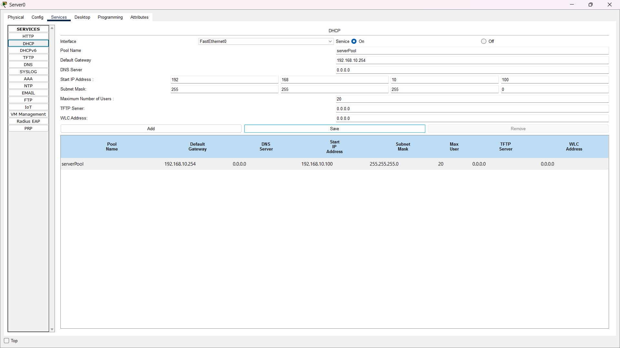
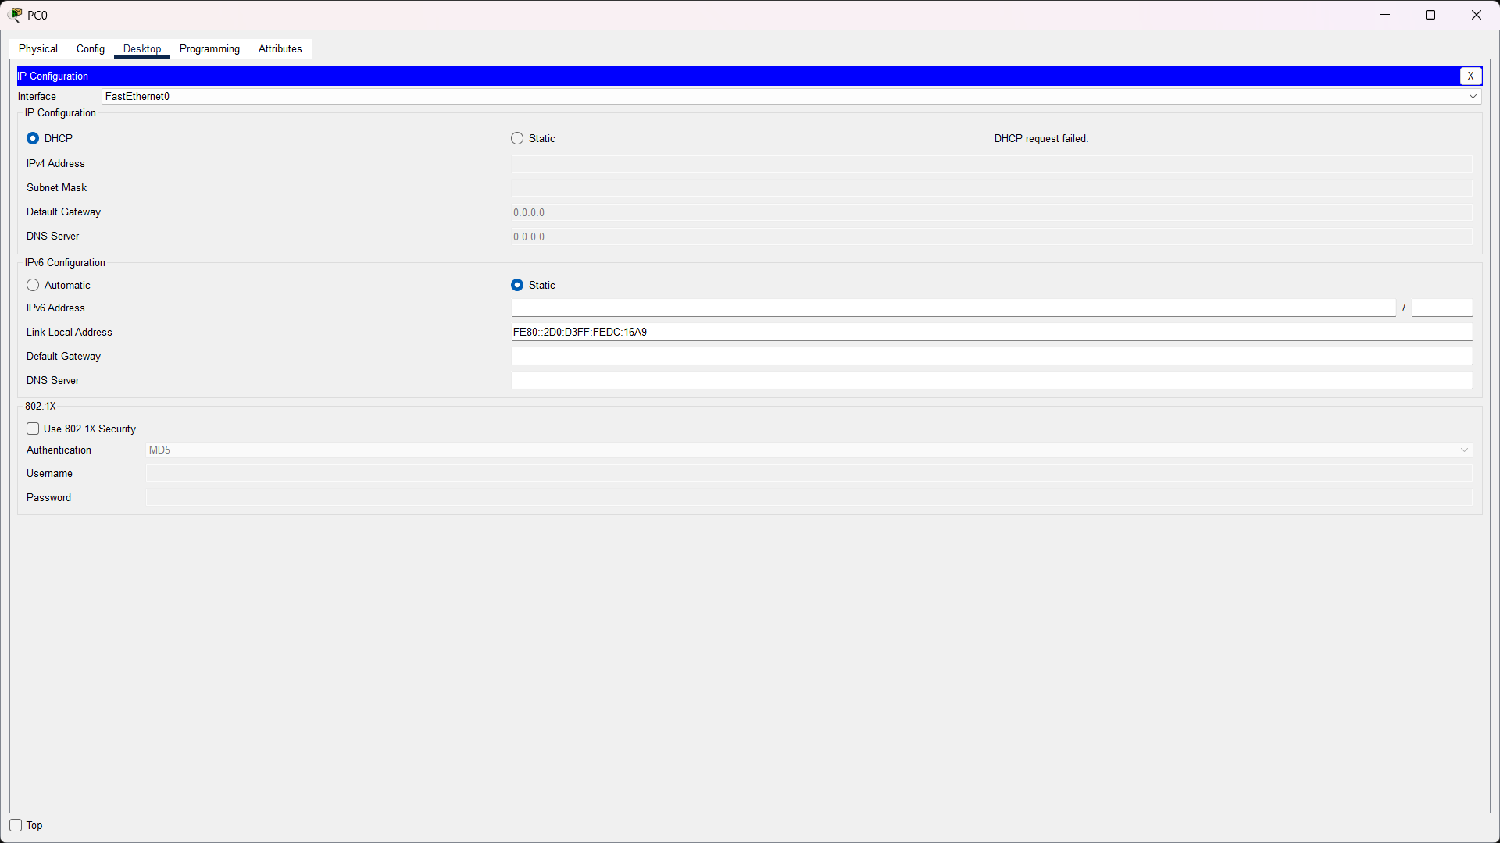
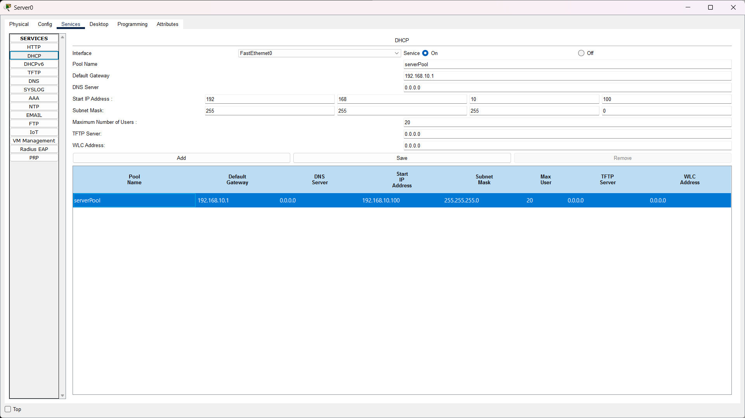
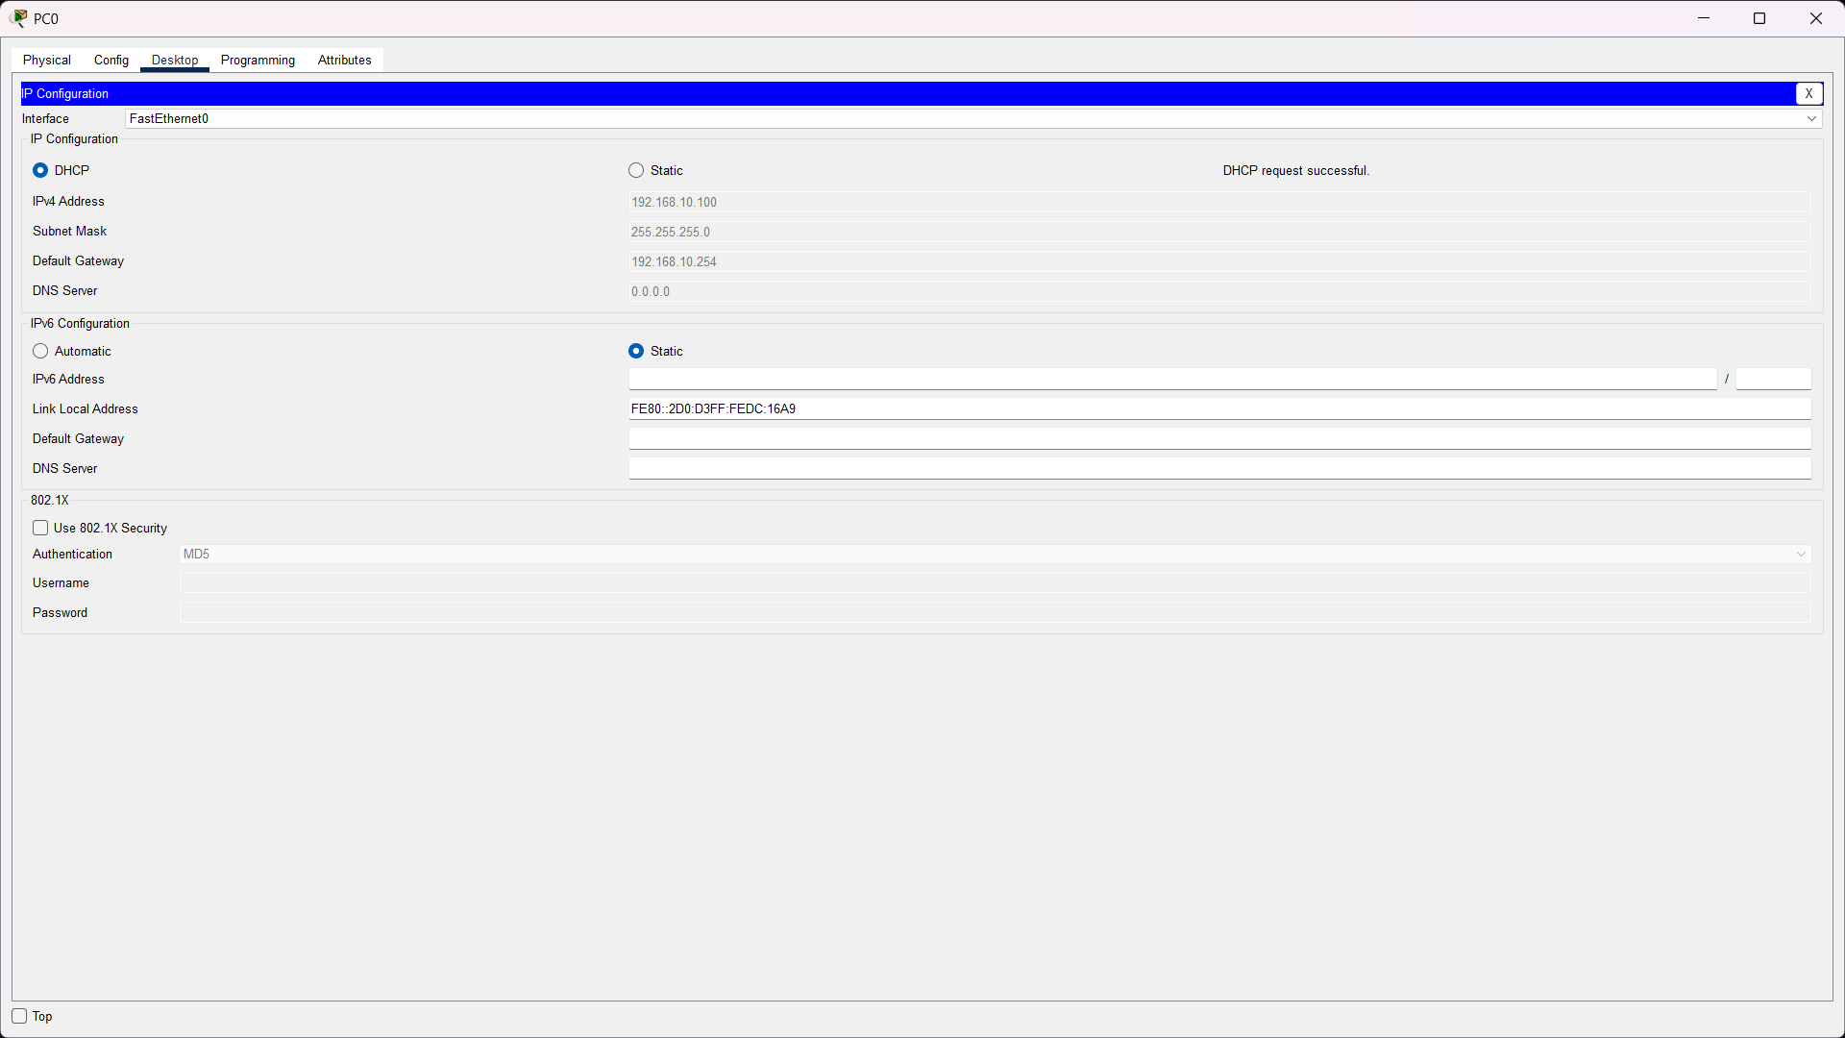

Q3. Diagnose “Websites Work by IP but Not by Name”
Meaning: If a device can reach a remote IP address but cannot reach the same service by hostname, basic IP connectivity is probably working and DNS should be checked.
- First ping the default gateway to confirm local connectivity.
- Ping a known reachable IP address. If the IP works, the network path is available.
- Run ipconfig /all (Windows) and note the configured DNS server address.
- Run nslookup www.example.com. Check which DNS server is being queried and whether it returns an answer or a timeout/error.
- Test the DNS server itself with ping where appropriate, or verify that the DNS service/server is online and reachable.
- Check whether the DHCP pool is distributing the correct DNS server address.
- Correct the DNS server setting. In a lab, this might mean changing the DHCP DNS field to the intended DNS server or fixing the DNS service configuration.
- Renew the client configuration, run ipconfig /flushdns, and repeat nslookup. Finally test the website name again.
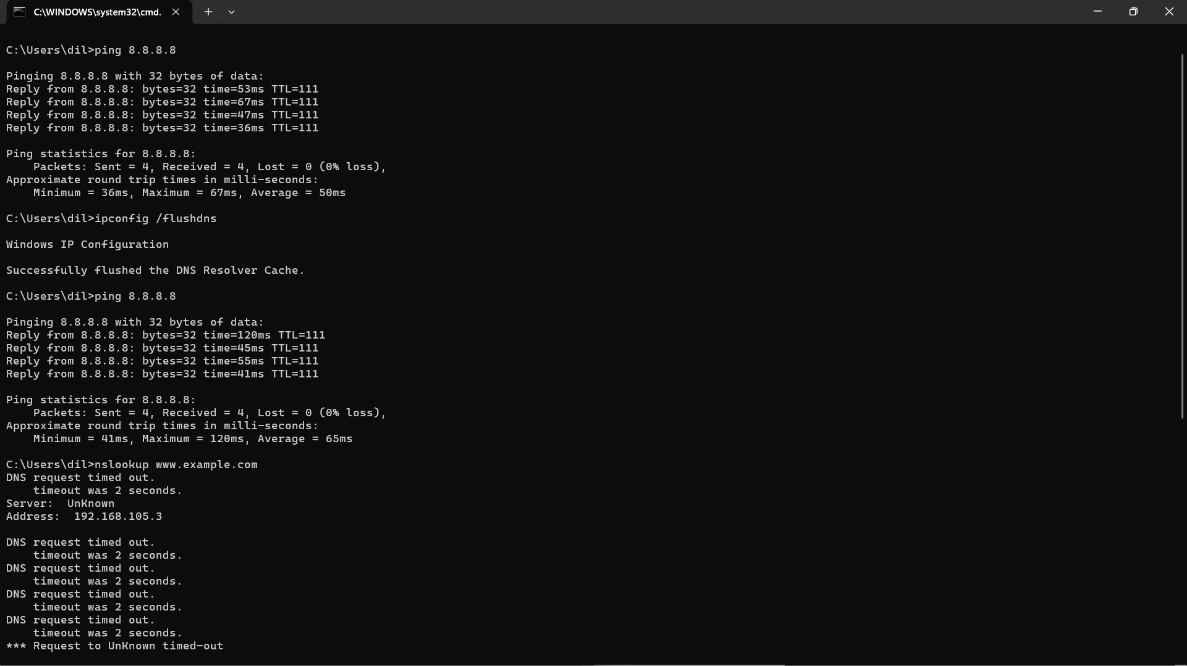
Solution: Restore a reachable, correctly configured DNS server and make sure clients receive its address. A successful nslookup should then return one or more IP addresses for the requested hostname.

Q4. Client Receives an APIPA Address (169.254.x.x)
APIPA is used by Windows when a DHCP-enabled interface cannot obtain a normal IPv4 lease. The typical APIPA range is 169.254.0.0/16.
Possible causes:
- DHCP server is turned off or the DHCP service is stopped.
- Client cable/link or switch port is disconnected/down.
- DHCP scope has no free addresses left.
- DHCP pool has incorrect settings or is not activated.
- Client and DHCP server are on different subnets and no DHCP relay/helper is configured.
- VLAN assignment or trunk configuration prevents DHCP messages from reaching the server.
- Firewall/security settings block DHCP traffic.
Step-by-step resolution:
- Check the physical/logical link and verify the NIC and switch port are up.
- Run ipconfig /all and confirm DHCP Enabled is Yes and the address is 169.254.x.x.
- Check that the DHCP server is powered on and its DHCP service is enabled.
- Inspect the DHCP scope and confirm free IP addresses are available.
- Confirm the client is in the correct VLAN/subnet. If the server is in another subnet, verify the router DHCP relay/ip helper configuration.
- Correct any pool, VLAN, relay, or connectivity problem found.
- Run ipconfig /release followed by ipconfig /renew, or request DHCP again in Packet Tracer.
- Verify that the client now receives a valid IP address, subnet mask, default gateway, and DNS server.
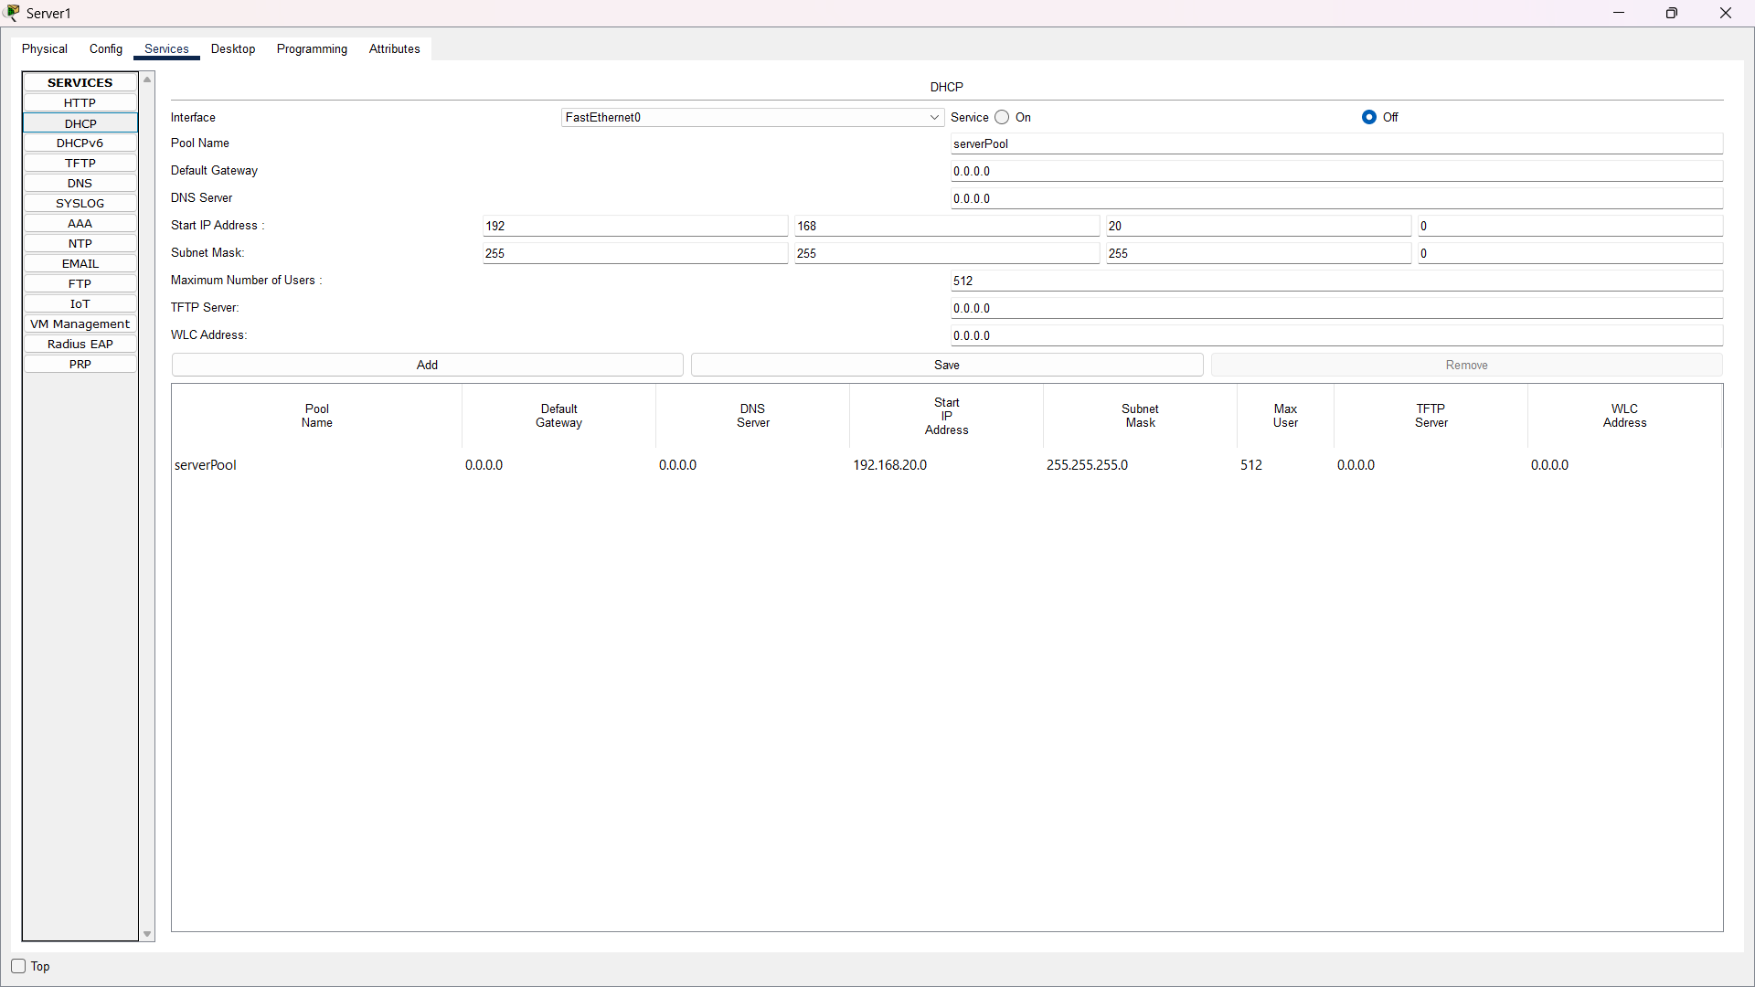
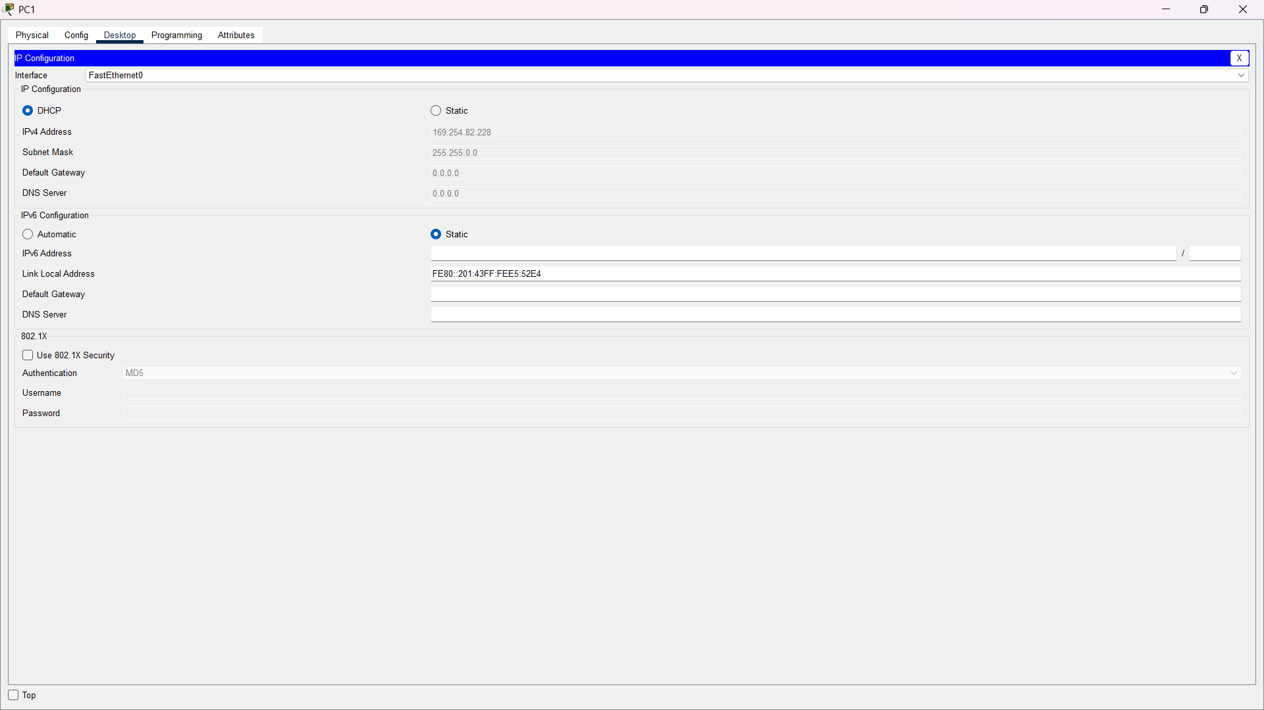
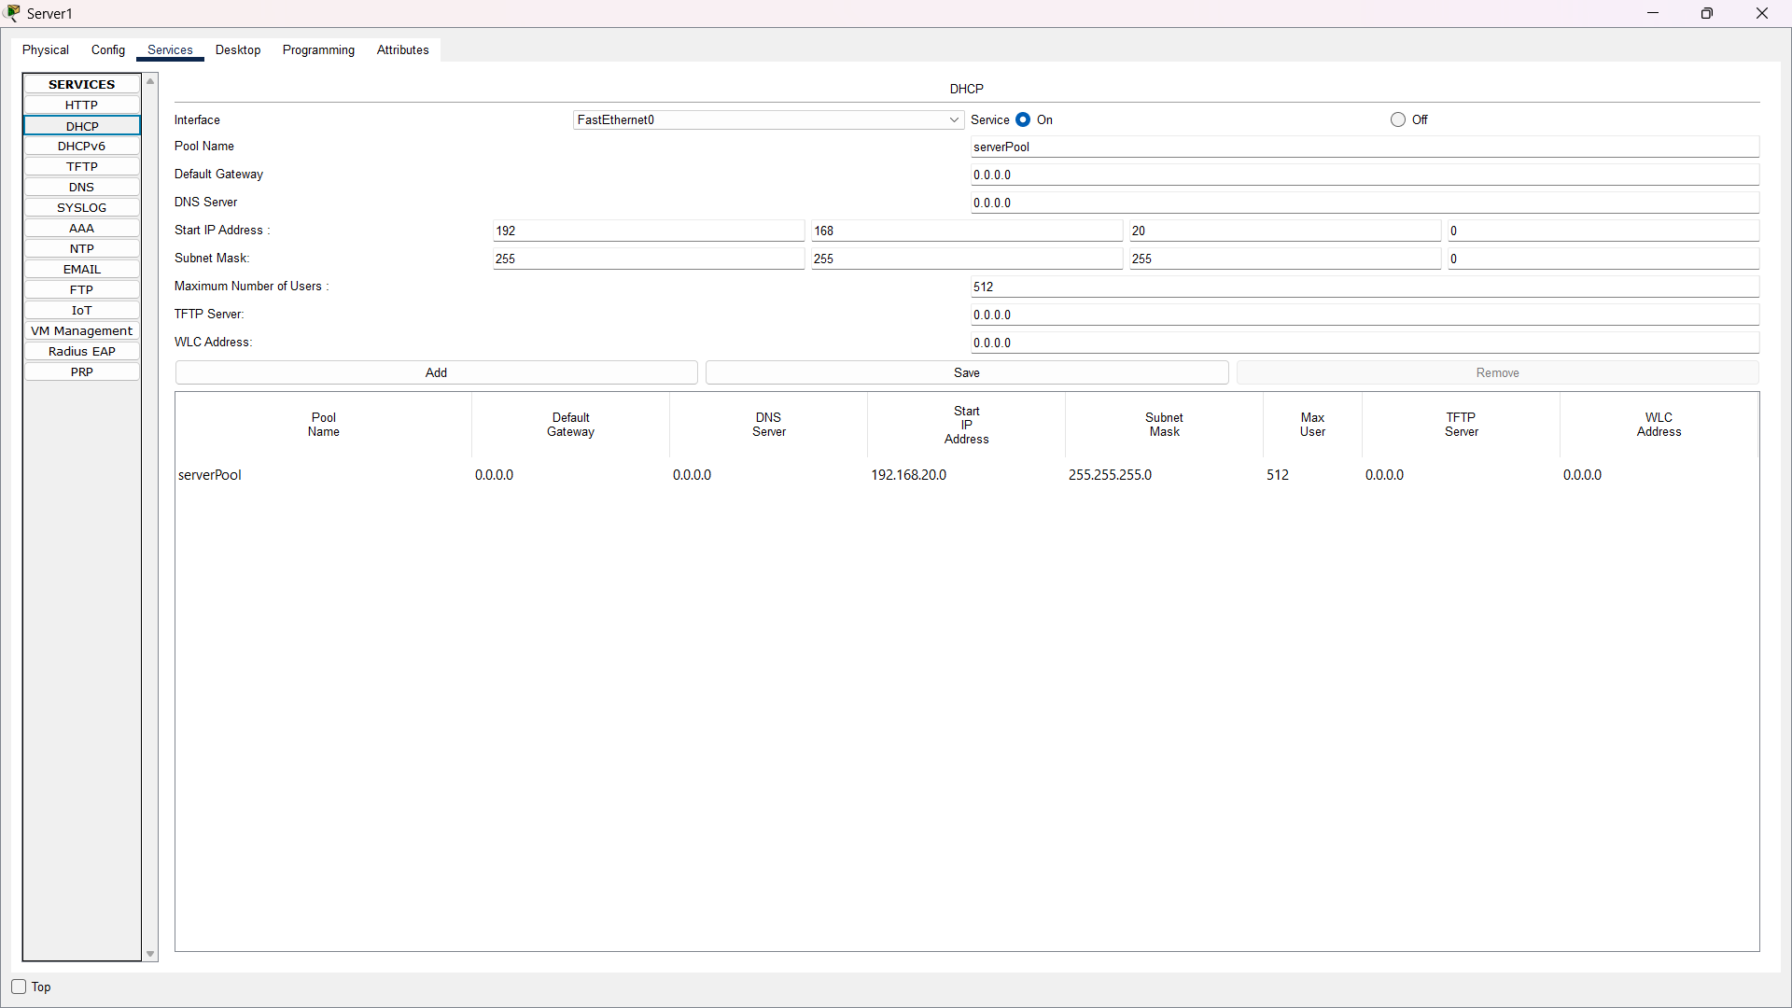
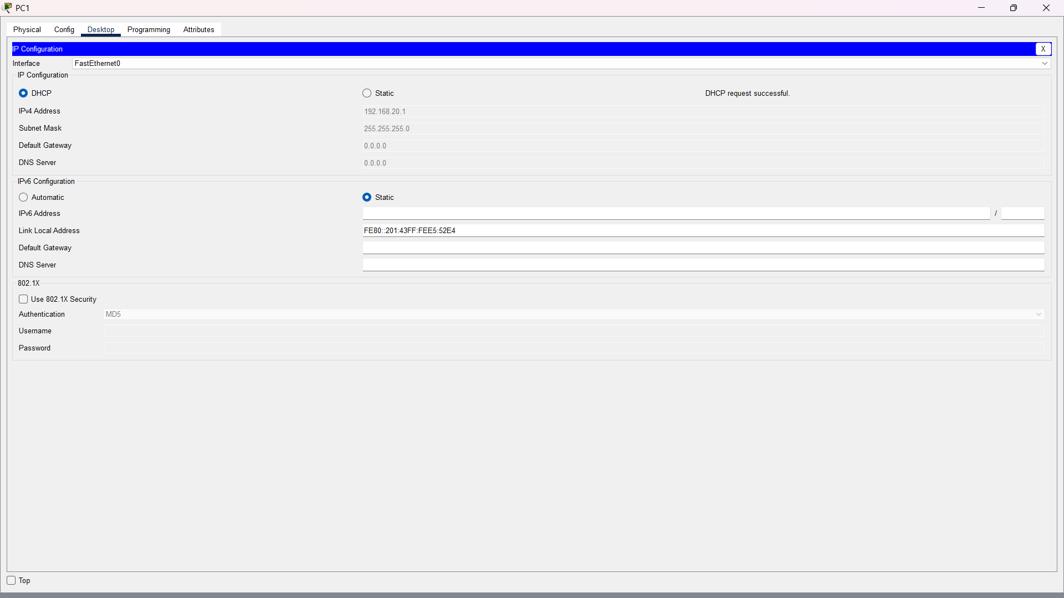

Q5. Common DNS and DHCP Issues
Type | Issue | Symptoms | Possible Cause | Recommended Solution
DNS | Wrong DNS server | Websites fail by name; IP connectivity may still work. | Incorrect DNS address from DHCP or manual settings. | Set the correct reachable DNS server, renew settings, and test with nslookup.
DNS | Bad hosts-file entry | One specific domain resolves to an unexpected IP. | Manual hosts-file mapping overrides DNS. | Remove/correct the hosts entry and run ipconfig /flushdns.
DNS | DNS server/service unavailable | nslookup times out or reports server failure. | DNS service stopped, server unreachable, firewall, or network fault. | Check server/service status, connectivity and firewall; restart/fix DNS service and retest.
DHCP | Incorrect default gateway | Client gets an IP but cannot reach remote networks. | Wrong gateway configured in DHCP scope. | Correct the scope gateway and renew the client lease.
DHCP | Scope exhausted | New clients fail to obtain a lease or may use APIPA. | All addresses in the DHCP pool are already leased/reserved. | Expand/adjust the pool, remove stale leases where appropriate, or reduce lease duration in a lab.
DHCP | DHCP server unreachable | Client receives 169.254.x.x and renew fails. | Server/service down, link/VLAN problem, or missing relay across subnets. | Restore connectivity/service, verify VLANs and DHCP relay, then renew the lease.

Conclusion
This practical demonstrates common DNS and DHCP failures and a simple troubleshooting method: verify connectivity, inspect the client configuration, test the relevant service, compare expected and actual settings, correct the configuration, and test again. DNS mainly affects name-to-IP resolution, while DHCP supplies client addressing information such as IP address, subnet mask, gateway, and DNS server.

